Test Akhir Praktikum Basis Data Pertemuan 2

Pancar Wahyu Setiabi

H1D024018

Shif D

1. Membuat database



MariaDB [test]> create database Pancar_H1D024018;

Query OK, 1 row affected (0.001 sec)

1. Melihat seluruh database pada mysql server

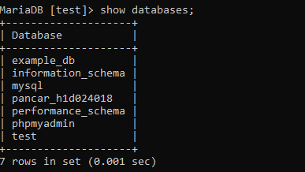

MariaDB [test]> show databases;

+--------------------+

| Database |

+--------------------+

| example_db |

| information_schema |

| mysql |

| pancar_h1d024018 |

| performance_schema |

| phpmyadmin |

| test |

+--------------------+

7 rows in set (0.001 sec)

1. Mengakses database/menggunakan database



MariaDB [test]> use Pancar_H1D024018;

Database changed

1. Menghapus database

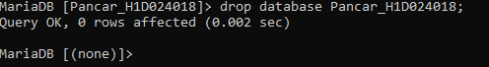

MariaDB [Pancar_H1D024018]> drop database Pancar_H1D024018;

Query OK, 0 rows affected (0.002 sec)

MariaDB [(none)]>